

**Project Proposal**

**ReadSphere**

**13016214 Software Engineering Principles Laboratory**

**Software Engineering Program,**

**Department of Computer Engineering,**

**School of Engineering, KMITL**

By

65011269 Budthbundit Thaya-Urai

65011593 Ravinan Woraratyanon

65011593 Thatchapon Chatthanes

**Introduction**

Welcome to ReadSphere, where the love for books meets the ease of modern technology! ReadSphere is your go-to destination for a delightful and hassle-free book shopping experience. Whether you're a fan of the crisp pages of a physical book or prefer the convenience of an e-book, we've got you covered. Our goal is simple: to make the joy of reading accessible to everyone, anytime, and anywhere.

In a fast-paced world, ReadSphere stands as a sanctuary for book enthusiasts, offering a diverse array of reading options to cater to your unique tastes. From the tangible pleasure of holding a novel in your hands to the portability of an e-book on your device, we believe that the magic of storytelling should be within reach for everyone.

Explore our curated selection of books, both physical and digital, and immerse yourself in the captivating world of literature. ReadSphere isn't just a platform; it's a community of book lovers who understand the importance of a good story.

Join us as we redefine the way you experience books. Whether you're looking to rent a book for a cozy night in or add a new gem to your personal library, ReadSphere is here to make your reading journey seamless and enjoyable. So, dive into the pages of your next adventure with ReadSphere – where reading is not just an activity but a delightful experience waiting to unfold.

**Description**

ReadSphere, designed as a web application, brings the magic of books directly to your screen. Whether you're an avid reader or just starting your literary journey, our user-friendly platform provides an immersive and tailored experience.

Key Features:

1. Rent and Buy Options:

* Choose between renting a physical book and having it delivered to your doorstep or purchasing a new book to add to your personal collection.
* Access a vast catalog of both physical and e-books, ensuring that every reader finds something to suit their preferences.

1. Delivery Service:

* Enjoy the convenience of having your selected physical books delivered directly to your home, making the reading experience hassle-free and delightful.

1. E-book Library:

* For those who prefer the portability and accessibility of digital books, ReadSphere provides an extensive e-book library with a wide range of genres and authors.

1. Payment Transaction System:

* A secure and user-friendly payment system ensures smooth transactions, providing a safe and reliable way to complete your book purchases or rentals.

1. User System:

* Create your personalized user account, allowing you to track your reading history, manage your bookshelf, and receive personalized recommendations based on your preferences.

1. Friend System:

* Connect with fellow book enthusiasts through our Friend System, fostering a sense of community and enabling users to share book recommendations, reviews, and engage in literary discussions.

1. Review System:

* Share your thoughts on the books you've read and discover new gems through the Review System. Contribute to a vibrant literary community by expressing your opinions and reading insights.

**UI Design**

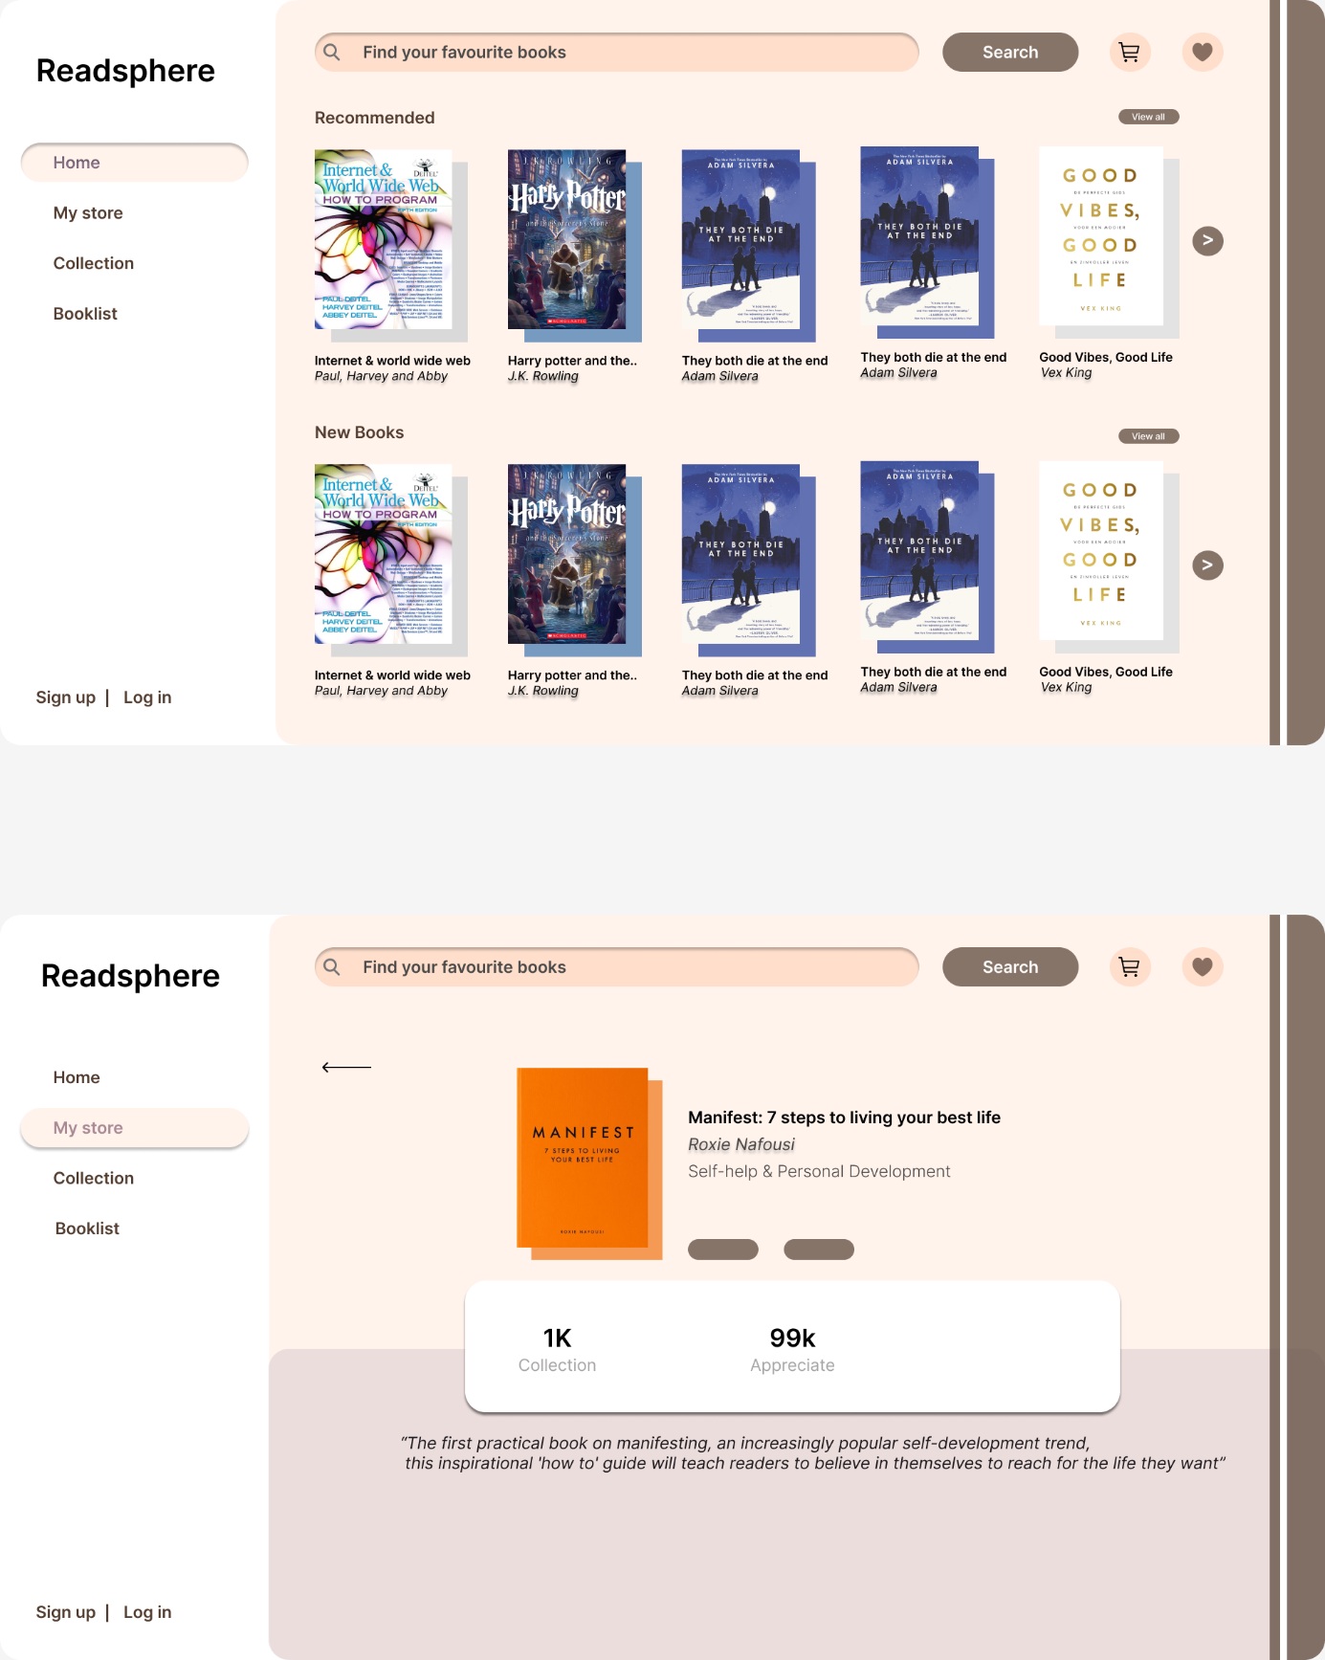

**Project Plan**

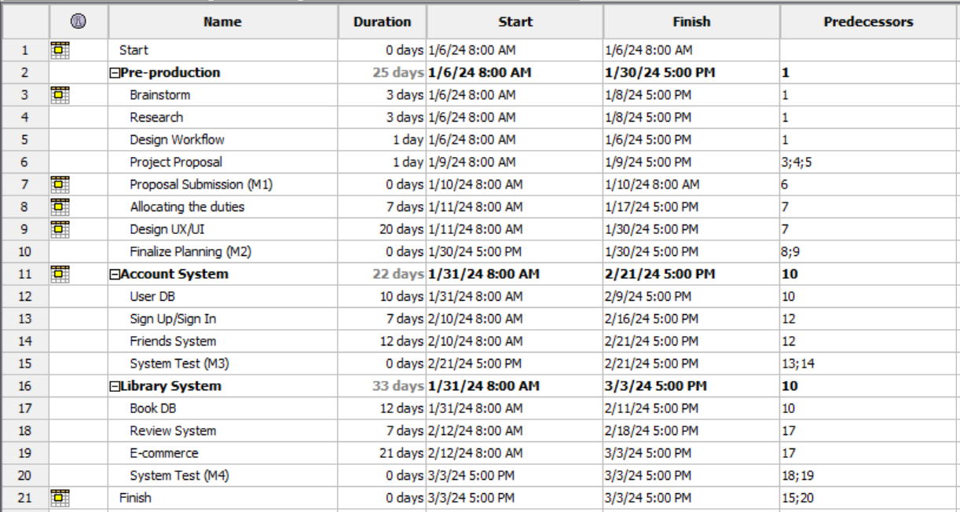

**Gantt Chart**

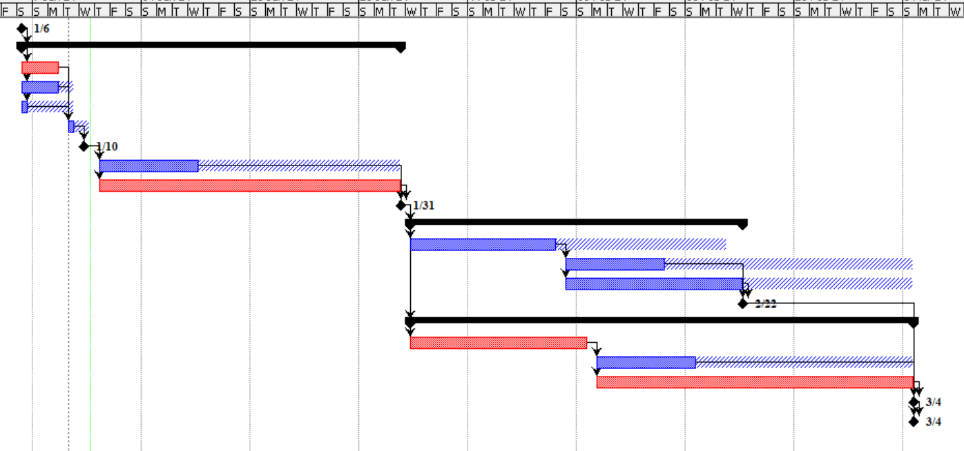

**Network Diagram**

